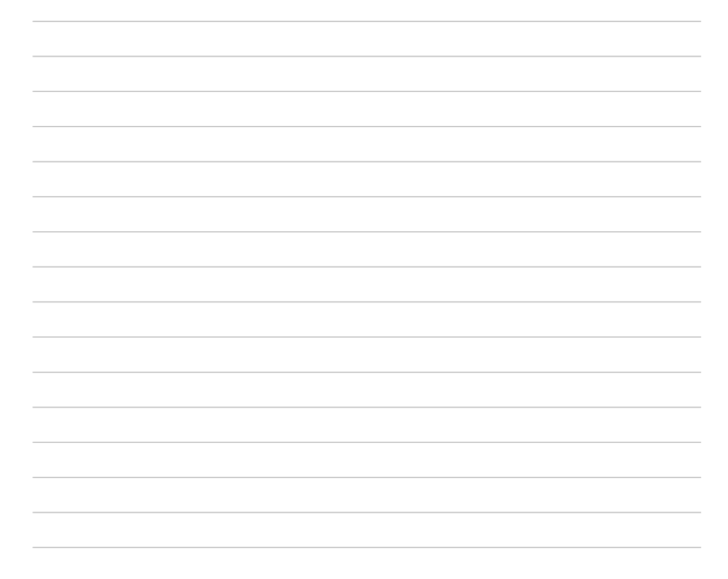
NOTE:.

slope-intercept form y = mx + b
NOTE :.
standard form Ax + By = C
Parallel perpendicular lines
NOTE :.
- The function f is defined by $f\left(x\right)=x+1.$ What is the y-intercept of the graph of y = f(x) in the xy-plane?
 A. (0,-3)
B. (0,-1)
C. (0,3)
D. (0,1)

- What is the x-intercept of the graph of the function f(x) = - 5x - 10 in the xy-plane,
A. (-5,0)
B. (-2,0)
C. (-10,0)
D. (10,0)
- line in the xy-plane passes through the points (2,6) and (6, 12). Which of the following is an equation of this line?
A. $y=\frac{3}{2}x+\frac{14}{3}$
B. $y=\frac{3}{2}x+3$
C. y = x + 8
D. $y=\frac{2}{3}x+\frac{14}{3}$

- Which of the following is an equation of the line in the xy-plane that contains the points (1,3) and (5,15)?
- $y=\frac{1}{2}x$
- y = 2x + 5
- y = 3x
- y = x + 2
- The table shows some values of x and their corresponding values of y. there is a linear relationship between x and y. Which of the following equations represents this relationship?
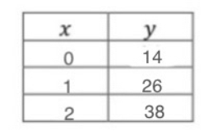
  - y = 0.5x - 2
  - y = 2x - 4
  - y = 0.5x + 2
  - y = 12x + 14

- The table above shows several values of x and their corresponding values of y, where k is a nonzero constant. If the relationship between x and y is linear, which of the following defines this relationship?
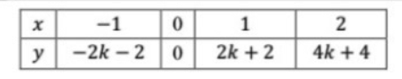
- y = -2kx
- y = kx
- y = -2k - x - 1
- y = 2x(k + 1)

- between the prices during an online sale, where x is the nonsale price, in dollars, of an item and y is the total sale price, in dollars, of the item including a shipping fee.
Which equation represents the relationship between x and y?
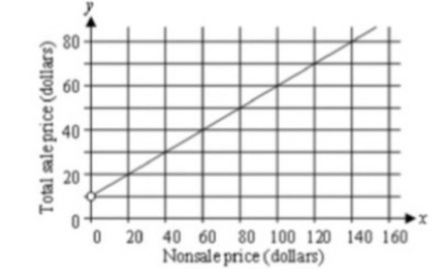
  - y = 2x + 10
  - y = 2x - 10
- C. $y=\frac{1}{2}x-10$
- D. $y=\frac{1}{2}x+10$

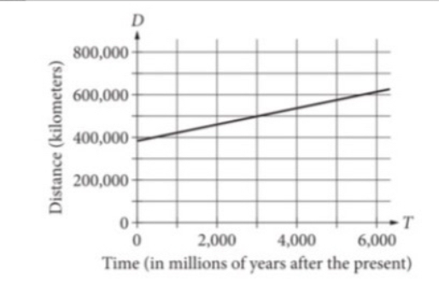
- The graph shown models the relationship between the distance D, in kilometers, from Earth to the Moon and the time T, in millions of years after the present. Which of the following equations models this relationship?
A. D = 38T - 385,000
B. D = -38T - 385,000
C. D = -38T + 385,000
- D. D = 38T + 385,000

- graph represents the total charges, in dollars, by a contractor for x hours of work. The contractor charges a onetime fee plus an hourly rate. What is the best interpretation of the slope of the graph?
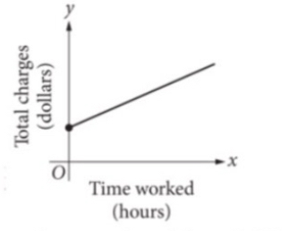
- The contractor’s hourly rate
- The maximum amount that the contractor charges
- The contractor’s onetime fee
- The total amount that the contractor charges

- The equation h = 250 + 20t gives the total number of housing units, h, in a community t months after a new zoning law was passed. How many housing units are added to the community each month after the zoning law was passed?
- 20
B. 260
C. 2500
D. 250

g(x) = 0.038x + 2.136
- The given linear function g models the annual percentage increase in the population of India x years after 1990. What is the best interpretation of g(10) = 1.486 in this context?
- 1.486 years after 1990, the percentage increase in the population of India was 10% over the previous year.
- 1.486 years after 1990, India's population was approximately 10 times its population in 1990.
- 10 years after 1990 India's population was approximately 1.486 times its population in 1990.
- 10 years after 1990, the percentage increase in the population of India was 1.486% over the previous year.

- A solution is formed by adding m grams of propylene glycol to 100 grams of water. For this solution, the freezing point, in kelvins, is modeled by the function
T(m) = 273.2 - 0.372m. Which of the following is the best interpretation of this statement "T(22) is approximately equal to 266" in this context?
- A solution formed by adding 266 grams of propylene glycol to 100 grams of water has an estimated freezing point of 22 kelvins.
- A solution formed by adding 22 grams of propylene glycol to 100 grams of water has an estimated freezing point of 266 kelvins.
- For every 22 grams of propylene glycol added to 100 grams of water, the freezing point of the solution is estimated to decrease by 266 kelvins.
- For every 266 grams of propylene glycol added to 100 grams of water, the freezing point of the solution is estimated to decrease by 22 kelvins.

- For a survey, students were assigned to either group R or group V. Combined, the students in both groups answered a total of 18 questions. Of these, a total of 6 questions were answered by the students in group V. The equation 3r + 6 = 18 describes this situation, where r represents the number of questions answered by each student in group R. Which of the following is the best interpretation of 3r in this context.
- The number of students in group V.
- The total number of questions answered by students in group V.
- The total number of questions answered by students in group R.
- The number of students at group R.

- Larry is training for a half marathon by going on a long run every Saturday. He will run 4 miles on the first Saturday of his training. Each Saturday after the first, he will run 2 more miles than he ran on the preceding Saturday. Which of the following equations represents the number of miles m Larry will run on the nth Saturday of his training?
- m = 2n + 2
- $m=2^{n}+3$
- m = 2n - 1
- m = 2n + 4

- When a zebra fish was 25 days old, the length of its tail fin was
3.0 millimeters (mm). The length of the fin increased by 0.06 mm each day for the next 175 days. Which of the following types of functions best describes how the fin length changed over time during this 175-day period?
- Decreasing exponential
- Increasing linear
- Increasing exponential
- Decreasing linear

- What is the x-coordinate of the x-intercept of the line with equation $\frac{2x}{3}+\frac{y}{3}=1$ when it is graphed in the xy- plane?
A. 2
B. 1
C. 1.5
D. 0.5

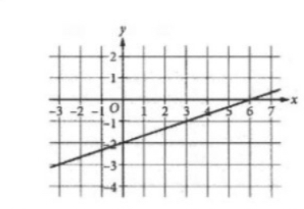
- An equation of the graph shown is ax + by = 8 where a and b are constants. What is the value of b?
- 2
- 4
- -4
- -2

- The equation 4x + 20y = 4,700 models the total number of trees in the neighborhood consisting of x-hectare park and 30-hectare residential area. The total number of trees in the neighborhood is 4,700. Which is the best interpretation of x in this context?
- The number of trees per hectare in the residential area.
- The total number of trees in the park.
- The number of trees per hectare in the park.
- The total number of trees in the residential area.

- The variable x and y are related such that each time x increases by 3, y decreases by 4.
If y = 8 and x = 0, which of the following equation expresses the relationship between x and y?
A. 3x - 4y = -32
B. 3x - 4y = 8
C. 3x + 4y = 32
D. 4x + 3y = 24
- Line L is defined by $y=\frac{1}{6}x-4.$ Line k is parallel to line l in the xy-plane. What is the slope of line k?
- $\frac{1}{6}$
- - 6
- $-\frac{1}{6}$
- 6
- Line p is defined by 4y + 8x = 18. Line r is perpendicular to line p in the xy-plane.
What is the slope of line r?
- 2
- -2
- $-\frac{1}{2}$
- $\frac{1}{2}$

- In the xy-plane, line k with equation y = mx + b, where m and b are constants, passes through the point (-3, 1). If line k is perpendicular to the line with equation y = -2x + 3, what is the value of b?
A. -0.5
B. 0.5
C. -2.5
D. 2.5

